FOOD JOURNEY – CHICKEN BREAST

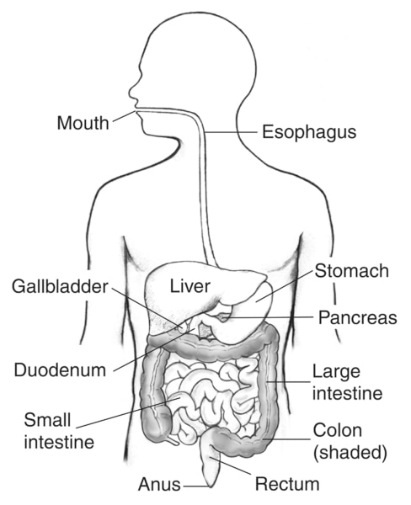

<https://www.niddk.nih.gov/media-assets/8896/N01520_H_thumbnail.jpg>

MOUTH AND OESOPHAGUS

Digestion begins at the mouth where the chicken breast enters. As it enters, the teeth tears and grinds the ingested food into small pieces which are more manageable for the body to digest. This process is mechanical digestion. As you chew the salivary glands release saliva into your mouth, containing digestive enzymes that start of the process of chemical digestion. Lingual lipase and salivary amylase (mostly) are the digestive enzymes found in the mouth. The lipase breaks down triglycerides (a kind of fat), while the amylase breaks down polysaccharides (a complex sugar that’s a carbohydrate).

Once chewed thoroughly, the saliva moistens the food to allow it to move more easily through the oesophagus into the stomach. The food and saliva mixture form a ball called bolus, which passes through the pharynx to the oesophagus. The epiglottis; a flap or “lid” which prevents the bolus from entering the trachea. The oesophagus, a muscular tube that leads from the mouth to the stomach, contracts in a wave-like movement and squeezes the bolus down its tract, this is the peristalsis.

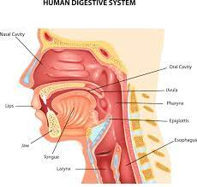

STOMACH

The stomach employs both mechanical and chemical digestion. The glands in the stomach lining make stomach acid and enzymes that break down the food. Muscles of the stomach mix with the chicken breast with these digestive juices, so it can pass to the small intestine.

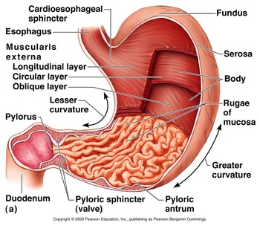

<http://thehumandigestivesystem1.weebly.com/uploads/2/9/0/8/29080435/6531005.jpg?352>

SMALL INTESTINE

The small intestine carries out most of the digestive process, absorbing almost all of the nutrients you get from the chicken breast into your bloodstream. The walls of the small intestine make digestive juices, which mixes with bile and pancreatic juice to complete the breakdown of proteins, carbohydrates, and fats. Your small intestine moves water from your bloodstream into your GI tract to help break down the chicken breast. Your small intestine also absorbs water with other nutrients.

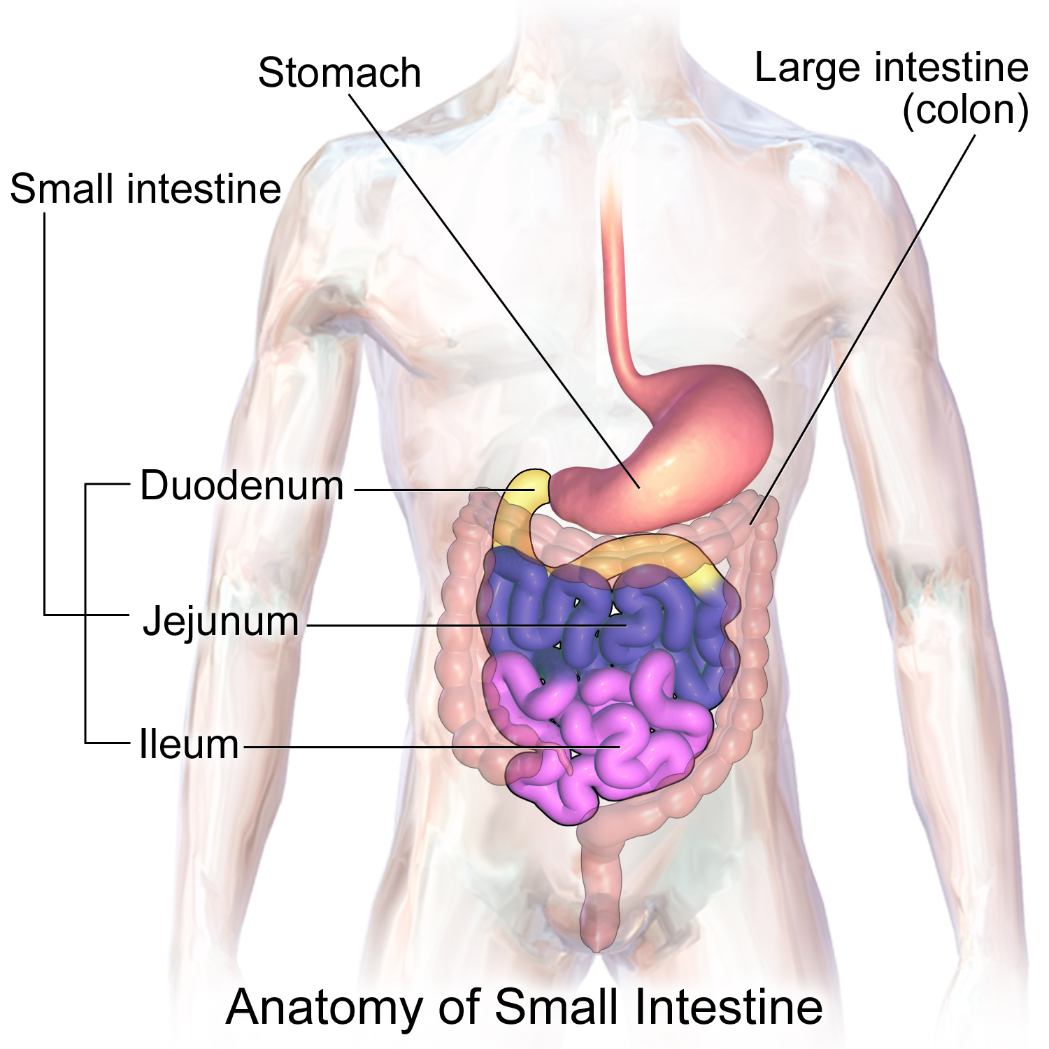

<https://upload.wikimedia.org/wikipedia/commons/7/77/Blausen_0817_SmallIntestine_Anatomy.png>

LARGE INTESTINE

Large intestine moves more water from your GI tract into your bloodstream. Bacteria in your large intestine help break down remaining nutrients and make vitamin K. waste products of digestion, including parts of chicken breast that are still too large, become stool.

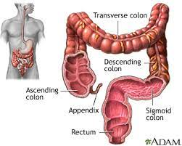

(Rachel Nall, 2018) (UPMC, 2022) (Britannica, 2020) (Justin J & Dhamoon, 2021) (Megan Dix, 2021)

ELIMINATION AND FAECES

The chicken breast molecules that cannot be digested or absorbed need to be eliminated from the body, the removal of indigestible wastes through the anus, in the form of feces, is defecation or elimination. Faeces are made up of 75% water and 25% solid matter (undigested food material, bacteria, left over bile components and cellular material).

# Bibliography

Britannica, t. e. (2020, May 13). *Mouth anatomy*. Retrieved from Britannica: https://www.britannica.com/science/mouth-anatomy

Justin J, P., & Dhamoon, A. S. (2021, 09 18). *physiology, digestion*. Retrieved from National library of medicine: https://www.ncbi.nlm.nih.gov/books/NBK544242/#:~:text=Enzymes%20from%20the%20salivary%20and,lipids%2C%20RNA%2C%20and%20DNA.

Megan Dix, R. B. (2021, 04 1). *how is protein digested?* Retrieved from healthline: https://www.healthline.com/health/protein-digestion

Rachel Nall, M. C. (2018, 09 05). *understading chemical digestion*. Retrieved from healthline: https://www.healthline.com/health/chemical-digestion

UPMC. (2022). *difference between small and large intestine*. Retrieved from UPMC children's hospital of Pittsburgh: https://www.chp.edu/our-services/transplant/intestine/education/about-small-large-intestines